**Mandate Screen**

1. **Mandate to be created only in Claims Adjustment Menu**
2. **To have a Grid and shows the created OD, PD, BI Claims**

|  |  |  |  |  |
| --- | --- | --- | --- | --- |
| **+ / -** | **Claimant’s Name** | **<< OD Claim Created >>** |  | **<< Add >>** |
| **--** |  | **OD Mandate #1** | **<< Status – Pending / Rejected / Approved >>** | **<< View >>** |
| **+ / -** |  | **<< PD Claims Created >>** |  | **<< Add >>** |
| **+ / -** |  | **<< BI Claims Created >>** |  | **<< Add >>** |

**Note:**

* **+ / - is to expand or collapse the list of mandates created for each Claim Type**
* **Status is changed to Pending after user has created and submitted a Mandate for Approval**
* **View is for user to click to see the details of the Mandate especially if Supervisor has approved or rejected the Mandate**

1. **At each time, there can only be 1 Mandate that can be created for each Claim Type and System must also checked that there’s Reserve for each Claim Type. Note: if there are multiple BI / PD Claims created, System will only allow 1 Mandate per Claim created.**
2. **Only when Status is Rejected or Approved the Add Button will be changed to Active Mode.**
3. **When Add Button is clicked, the Screen will show the relevant Claim Type Mandate Request Screen – to follow the Supervisor Mandate Approval Screen**
4. **To create different User Rights for Claim Officers Group and Supervisor Group – Claim Officers can create Mandate Request so the Supervisor’s Mandate Columns and Supervisors’ Approval Sections will be grayed out whereas for Supervisor Group, they can only edit the Approval Section and the Supervisor’s Mandate Columns**
5. **When Claim Officer creates and submits a Mandate Request, Supervisor will be updated on the diary screen and he can click on that entry to bring him to the Mandate Screen in Claims Adjustment.**
6. **Minimum Offer Column to be removed for all Mandate Claims Request**
7. **Maximum Offer Values entered by the Claim Officers will be reflected in the Supervisor’s Mandate’s Maximum Offer Value.**
8. **Approval by Supervisor means that System will accept all the values as reflected in the Supervisor’s Mandate Column. These values will be reflected and be used for Payment purposes.**
9. **Rejected by Supervisor means that System will not accept the values reflected in the Supervisor’s Mandate Column.**
10. **Approval and Rejection Status can be changed anytime as long as there are no payments being made against it. If there is payment made against it, System will not allow Supervisor to change the Mandate Approval Status.**
11. **Example of how Users will create Second Mandate Request when a Previous Mandate Request has been Approved:**
    1. **OD Mandate #1 – Status Approved – Cost Of Repairs Field: $5000**
    2. **If there is no Payment. OD Mandate #2 Creation – Cost Of Repairs Field will reflect $5000 and User can edit the $5000 upwards and System will not allow User to edit the value lower.**
    3. **If there is a Payment of $2000 being made against OD Mandate #1 for Cost of Repairs, the value will be revised to $5000 - $2000 = $3000 and store in the backend**
    4. **So when OD Mandate #2 is being created, Cost Of Repairs Field will reflect $3000 and user can edit upwards and not allowed to edit downwards.**
    5. **Payment will always use the latest values from the latest Approved Mandate Request**
12. **Exact Screen fields – please follow CRIS Plus Fields Layout V4.xlsx**

**PD Mandate Screen for CO And Supervisor**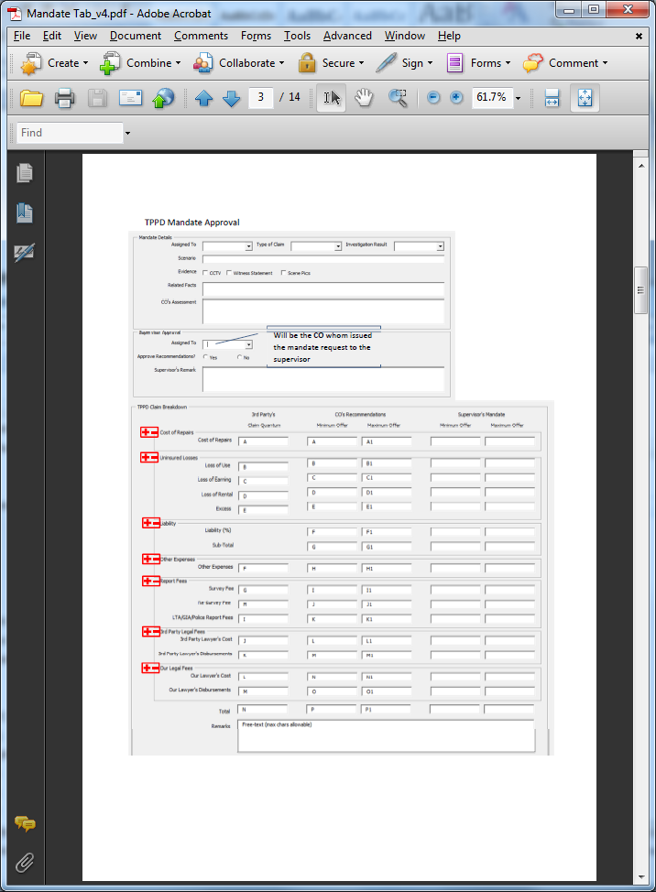

**BI Mandate Screen For CO And Supervisor**

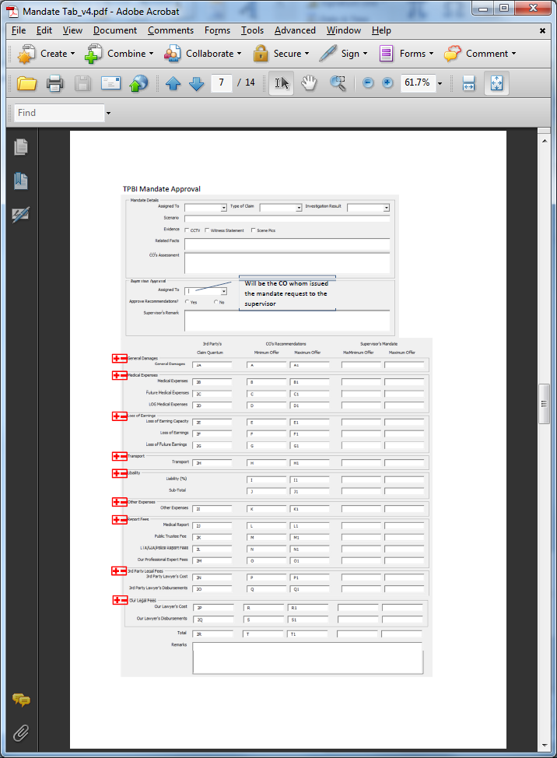

**OD Mandate Screen**

